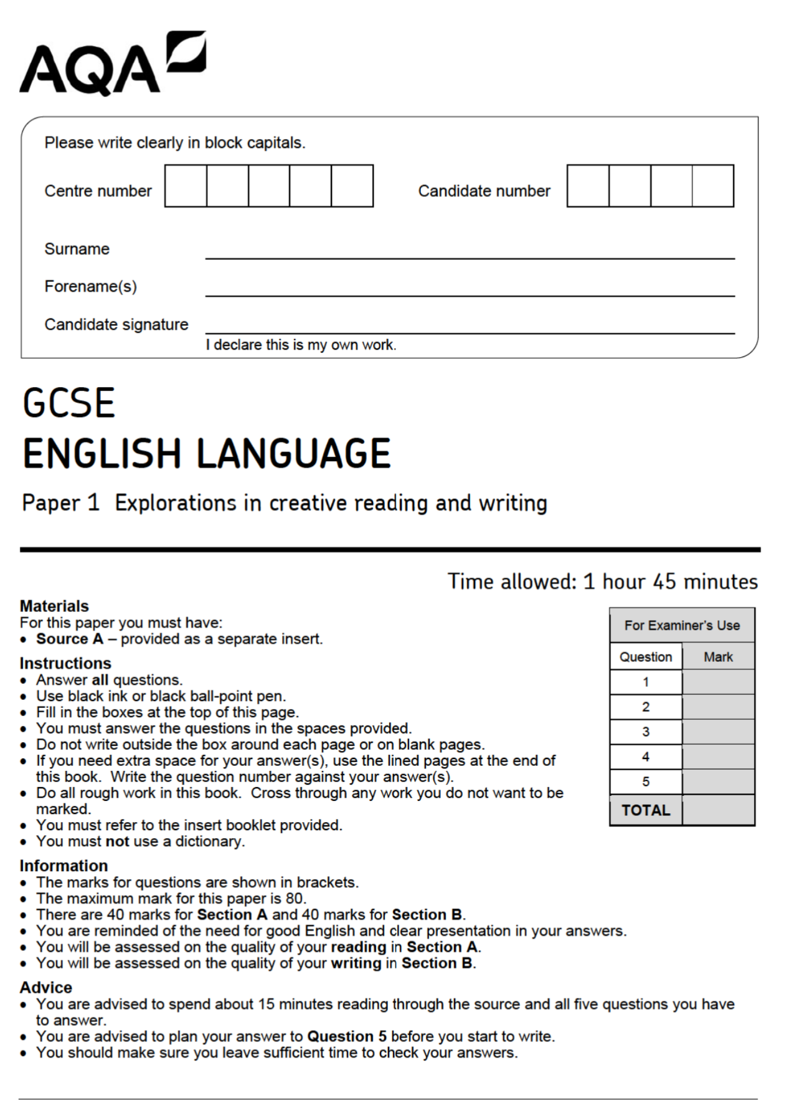
Extract 1 - Questions: Mr Fisher (June 2018)

01: Read again lines 1 to 4.
Answer all part of this question.
Tick (✓) one box for each question.

01.1 Who does Mr Fisher live with?
He lives with his cat
He lives on his own
He lives with his mother
[1 mark]
01.2 Where is Mr Fisher’s house?
In the centre of town
In the centre of a village
In the outskirts of town
[1 mark]
01.3 Why did he prefer to do his marking at school?
To take more home
So he could do it at the
weekend
He didn’t have a car
[1 mark]
01.4 What does he normally have to take home on the bus?
Books and papers
His packed lunch
His teacher planner
[1 mark]
Q2: Read again lines 9 to 15.
Mr Fisher remembered a time – surely, not so long ago – when books were golden, when imaginations soared, when the world was filled with stories which ran like gazelles and pounced like tigers and exploded like rockets, illuminating minds and hearts. He had seen it happen; had seen whole classes swept away in the fever. In those days, there were heroes; there were dragons and dinosaurs; there were space adventurers and soldiers of fortune and giant apes. In those days, thought Mr Fisher, we dreamed in colour, though films were in black and white, and good always triumphed in the end.

How does the writer use language here to convey Mr Fisher’s views on books and stories of the past?
You could include the writer’s choice of:
• Words and phrases
• Language features and techniques
• Sentence forms
[8 marks]

__________________________________________________________________________________________________________________________________________________________________________________________________________________________________________________________________________________________________________________________________________________________________________________________________________________________________________________________________________________________________________________________________________________________________________________________________________________________________________________________________________________________________________________________________________________________________________________________________________________________________________________________________________________________________________________________________________________________________________________________________________________________________________________________________________________________________________________________________________________________________________________________________________________________________________________________________________________________________________________________________________________________________________________________________________________________________________________________________________________________________________________________________________________________________________________________________________________________________________________________________________________________________________________________________________________________________________________________________________________________________________________________________________________________________________________________________________________________________________________________________________________________________________________________________________________________________________________________________________________________________________________________________________________________________________________________________________________________________________________________________________________________________________________________________________________________________________________________________________________________________________________________________________________________________________________________________________________________________________________________________________________________________________________________________________________________________________________________________________________________________________________________________________________________________________________________________________________________________________________________________________________________________________________________________________________________________________________________________________________________________________________________________________________________________________________________________________________________________________________________________________________________________________________________________________________________________________________________________________________________________________________________________________________________________________________________________________________________________________________________________________________________________________________________________________________________________________________________________________________________________________________________________________________________________________________________________________________________________________________________________________________________________________________________________________________________________________________________________________________________________________________________________________________________________________________________________________________________________________________________________________________________________________________________________________________________________________________________________________________________________________________________________________________________________________________________________________________________________________________________________________________________________________________________________________________________________________________________________________________________________________________________________________________________________________________________________________________________________________________________________________________________________________________________________________________________________________________________________________________________________________________________________________________________________________________________________________________________________________________________________________________________________________________________________________________________________________________________________________________________________________________________________________________________________________________________________________________________________________________________________________________________________________________________________________________________________________________________________________________________________________________________________________________________________________________________________________________________________________________________________________________________________________________________________________________________________________________________________________________________________________________________________________________________________
Q3: You now need to think about the structure of the source as a whole.
How has the writer structured the text to create excitement?
You could write about:
• How excitement has increased or decreased by the end of the source
• How the write uses structure to create an effect
• The writer’s use of any other structural features, such as changes in mood, tone or perspective
[8 marks]

__________________________________________________________________________________________________________________________________________________________________________________________________________________________________________________________________________________________________________________________________________________________________________________________________________________________________________________________________________________________________________________________________________________________________________________________________________________________________________________________________________________________________________________________________________________________________________________________________________________________________________________________________________________________________________________________________________________________________________________________________________________________________________________________________________________________________________________________________________________________________________________________________________________________________________________________________________________________________________________________________________________________________________________________________________________________________________________________________________________________________________________________________________________________________________________________________________________________________________________________________________________________________________________________________________________________________________________________________________________________________________________________________________________________________________________________________________________________________________________________________________________________________________________________________________________________________________________________________________________________________________________________________________________________________________________________________________________________________________________________________________________________________________________________________________________________________________________________________________________________________________________________________________________________________________________________________________________________________________________________________________________________________________________________________________________________________________________________________________________________________________________________________________________________________________________________________________________________________________________________________________________________________________________________________________________________________________________________________________________________________________________________________________________________________________________________________________________________________________________________________________________________________________________________________________________________________________________________________________________________________________________________________________________________________________________________________________________________________________________________________________________________________________________________________________________________________________________________________________________________________________________________________________________________________________________________________________________________________________________________________________________________________________________________________________________________________________________________________________________________________________________________________________________________________________________________________________________________________________________________________________________________________________________________________________________________________________________________________________________________________________________________________________________________________________________________________________________________________________________________________________________________________________________________________________________________________________________________________________________________________________________________________________________________________________________________________________________________________________________________________________________________________________________________________________________________________________________________________________________________________________________________________________________________________________________________________________________________________________________________________________________________________________________________________________________________________________________________________________________________________________________________________________________________________________________________________________________________________________________________________________________________________________________________________________________________________________________________________________________________________________________________________________________________________________________________________________________________________________________________________________________________________________________________________________________________________________________________________________________________________________________________________________________________________________________________________________________________________________________________________________________________________________________________________________________________________________________________________________________________________________________________________________________________________________
Q4: Focus this part of your answer from line 25 to the end of the extract.
In this part of the source, it is clear that Tibbet’s story is better than Mr Fisher expected and his reaction is extreme.
To what extent do you agree or disagree with this statement?
In your response, you could:
• consider your impressions of Mr Fisher’s expectations and his reaction
• comment on the methods the writer uses to present Mr Fisher’s expectations and reactions
• support your response with references to the text
[20 marks]

__________________________________________________________________________________________________________________________________________________________________________________________________________________________________________________________________________________________________________________________________________________________________________________________________________________________________________________________________________________________________________________________________________________________________________________________________________________________________________________________________________________________________________________________________________________________________________________________________________________________________________________________________________________________________________________________________________________________________________________________________________________________________________________________________________________________________________________________________________________________________________________________________________________________________________________________________________________________________________________________________________________________________________________________________________________________________________________________________________________________________________________________________________________________________________________________________________________________________________________________________________________________________________________________________________________________________________________________________________________________________________________________________________________________________________________________________________________________________________________________________________________________________________________________________________________________________________________________________________________________________________________________________________________________________________________________________________________________________________________________________________________________________________________________________________________________________________________________________________________________________________________________________________________________________________________________________________________________________________________________________________________________________________________________________________________________________________________________________________________________________________________________________________________________________________________________________________________________________________________________________________________________________________________________________________________________________________________________________________________________________________________________________________________________________________________________________________________________________________________________________________________________________________________________________________________________________________________________________________________________________________________________________________________________________________________________________________________________________________________________________________________________________________________________________________________________________________________________________________________________________________________________________________________________________________________________________________________________________________________________________________________________________________________________________________________________________________________________________________________________________________________________________________________________________________________________________________________________________________________________________________________________________________________________________________________________________________________________________________________________________________________________________________________________________________________________________________________________________________________________________________________________________________________________________________________________________________________________________________________________________________________________________________________________________________________________________________________________________________________________________________________________________________________________________________________________________________________________________________________________________________________________________________________________________________________________________________________________________________________________________________________________________________________________________________________________________________________________________________________________________________________________________________________________________________________________________________________________________________________________________________________________________________________________________________________________________________________________________________________________________________________________________________________________________________________________________________________________________________________________________________________________________________________________________________________________________________________________________________________________________________________________________________________________________________________________________________________________________________________________________________________________________________________________________________________________________________________________________________________________________________________________________________________________________________________________________________________________________________________________________________________________________________________________________________________________________________________________________________________________________________________________________________________________________________________________________________________________________________________________________________________________________________________________________________________________________________________________________________________________________________________________________________________________________________________________________________________________________________________________________________________________________________________________________________________________________________________________________________________________________________________________________________________________________________________________________________________________________________________________________________________________________________________________________________________________________________________________________________________________________________________________________________________________________________________________________________________________________________________________________________________________________________________________________________________________________________________________________________________________________________________________________________________________________________________________________________________________________________________________________________________________________________________________________________________________________________________________________________________________________________________________________________________________________________________________________________________________________________________________________________________________________________________________________________________________________________________________________________________________________________________________________________________________________________________________________________________________________________________________________________________________________________________________________________________________________________________________________________________________________________________________________________________________________________________________________________________________________________________________________________________________________________________________________________________________________________________________________________________________________________________________________________________________________________________________________________________________________________________________________________________________________________________________________________________________________________________________________________________________________________________________________________________________________________________________________________________________________________________________________________________________________________________________________________________________________________________________________________________________________________________________________________________________________________________________________________________________________________________________________________________________________________________________________________________________________________________________________________________________________________________________________________________________________________________________________________________________________________________________________________________________________________________________________________________________________________________________________________________________________________________________________________________________________________________________________________________________________________________________________________________________________________________________________________________________________________________________________________________________________________________________________________________________________________________________________________________________________________________________________________________________




