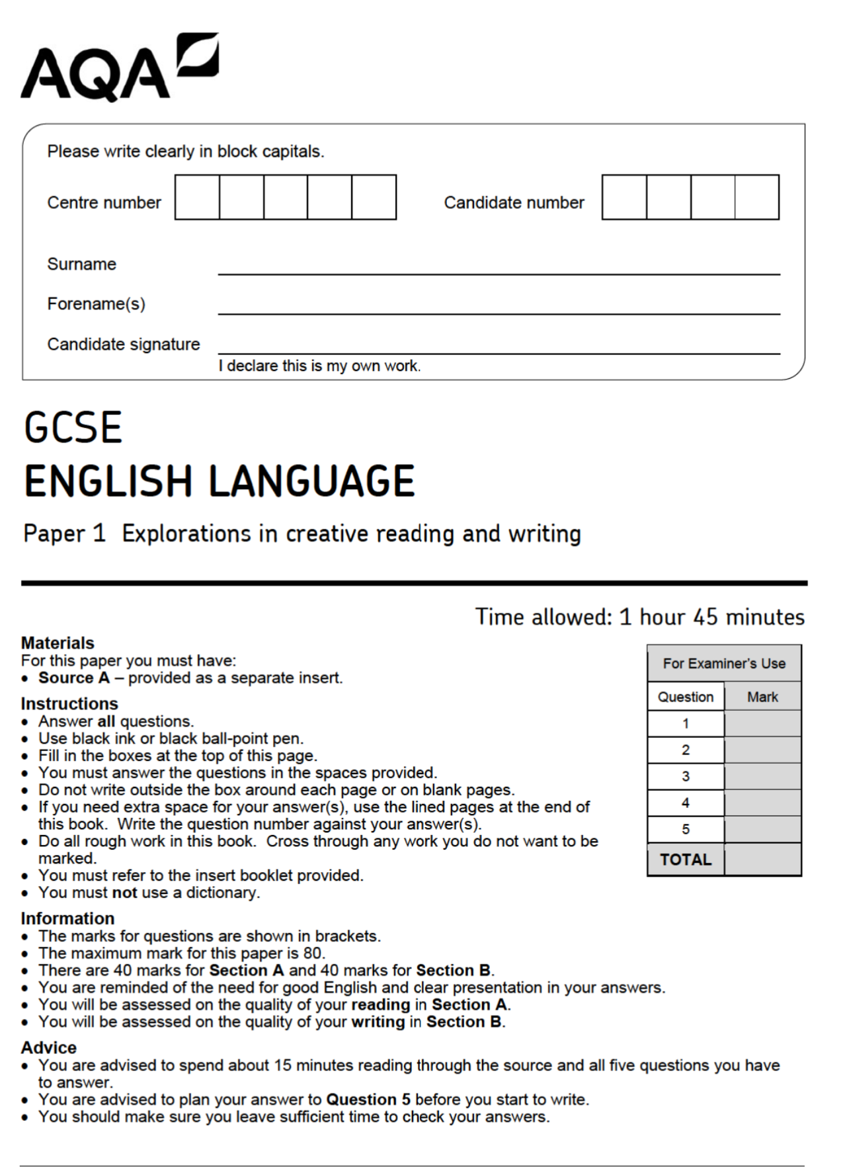

01: Read again lines 1 to 5.
Answer all part of this question.
Tick (✓) one box for each question.

01.1 What type of flowers does Rosabel buy?
Roses
Violets
Tulips
[1 mark]
01.2 What did she eat for tea?
A scone and an egg
A sandwich
Soup
[1 mark]
01.3 Where does Rosabel work?
A hat shop
A tea shop
A flower shop
[1 mark]
01.4 How is Rosabel travelling?
By taxi
By tram
By bus
[1 mark]
Q2: Look in detail at this extract, from lines 6 to 14 of the source:
Rosabel looked out of the windows; the street was blurred and misty, but light striking on
the panes turned their dullness to opal and silver, and the jewellers' shops seen through
this were fairy palaces. Her feet were horribly wet, and she knew the bottom of her skirt and
petticoat would be coated with black, greasy mud. There was a sickening smell of warm
humanity – it seemed to be oozing out of everybody in the bus – and everybody had the
same expression, sitting so still, staring in front of them. Rosabel stirred suddenly and
unfastened the two top buttons of her coat… she felt almost stifled. Through her
half-closed eyes, the whole row of people on the opposite seat seemed to resolve into one
meaningless, staring face.

How does the writer use language here to describe Rosabel’s bus journey home?
You could include the writer’s choice of:
• words and phrases
• Language features and techniques
• Sentence forms
[8 marks]

________________________________________________________________________________________________________________________________________________________________________________________________________________________________________________________________________________________________________________________________________________________________________________________________________________________________________________________________________________________________________________________________________________________________________________________________________________________________________________________________________________________________________________________________________________________________________________________________________________________________________________________________________________________________________________________________________________________________________________________________________________________________________________________________________________________________________________________________________________________________________________________________________________________________________________________________________________________________________________________________________________________________________________________________________________________________________________________________________________________________________________________________________________________________________________________________________________________________________________________________________________________________________________________________________________________________________________________________________________________________________________________________________________________________________________________________________________________________________________________________________________________________________________________________________________________________________________________________________________________________________________________________________________________________________________________________________________________________________________________________________________________________________________________________________________________________________________________________________________________________________________________________________________________________________________________________________________________________________________________________________________________________________________________________________________________________________________________________________________________________________________________________________________________________________________________________________________________________________________________________________________________________________________________________________________________________________________________________________________________________________________________________________________________________________________________________________________________________________________________________________________________________________________________________________________________________________________________________________________________________________________________________________________________________________________________________________________________________________________________________________________________________________________________________________________________________________________________________________________________________________________________________________________________________________________________________________________________________________________________________________________________________________________________________________________________________________________________________________________________________________________________________________________________________________________________________________________________________________________________________________________________________________________________________________________________________________________________________________________________________________________________________________________________________________________________________________________________________________________________________________________________________________________________________________________________________________________________________________________________________________________________________________________________________________________________________________________________________________________________________________________________________________________________________________________________________________________________________________________________________________________________________________________________________________________________________________________________________________________________________________________________________________________________________________________________________________________________________________________________________________________________________________________________________________________________________________________________________________________________________________________________________________________________________________________________________________________________________________________________________________________________________________________________________________________________________________________________________________________________________________________________________________________________________________________________________________________________________________________
Q3: You now need to think about the structure of the source as a whole.
How has the writer structured the text to highlight a contrast between the experiences of the two women?
You could write about:
• How the contrast is made more or less evident by the end of the source
• How the write uses structure to create an effect
• The writer’s use of any other structural features, such as changes in mood, tone or perspective
[8 marks]

__________________________________________________________________________________________________________________________________________________________________________________________________________________________________________________________________________________________________________________________________________________________________________________________________________________________________________________________________________________________________________________________________________________________________________________________________________________________________________________________________________________________________________________________________________________________________________________________________________________________________________________________________________________________________________________________________________________________________________________________________________________________________________________________________________________________________________________________________________________________________________________________________________________________________________________________________________________________________________________________________________________________________________________________________________________________________________________________________________________________________________________________________________________________________________________________________________________________________________________________________________________________________________________________________________________________________________________________________________________________________________________________________________________________________________________________________________________________________________________________________________________________________________________________________________________________________________________________________________________________________________________________________________________________________________________________________________________________________________________________________________________________________________________________________________________________________________________________________________________________________________________________________________________________________________________________________________________________________________________________________________________________________________________________________________________________________________________________________________________________________________________________________________________________________________________________________________________________________________________________________________________________________________________________________________________________________________________________________________________________________________________________________________________________________________________________________________________________________________________________________________________________________________________________________________________________________________________________________________________________________________________________________________________________________________________________________________________________________________________________________________________________________________________________________________________________________________________________________________________________________________________________________________________________________________________________________________________________________________________________________________________________________________________________________________________________________________________________________________________________________________________________________________________________________________________________________________________________________________________________________________________________________________________________________________________________________________________________________________________________________________________________________________________________________________________________________________________________________________________________________________________________________________________________________________________________________________________________________________________________________________________________________________________________________________________________________________________________________________________________________________________________________________________________________________________________________________________________________________________________________________________________________________________________________________________________________________________________________________________________________________________________________________________________________________________________________________________________________________________________________________________________________________________________________________________________________________________________________________________________________________________________________________________________________________________________________________________________________________________________________________________________________________________________________________________________________________________________________________________________________________________________________________________________________________________________________________________________________________________________________________________________________________________________________________________________________________________________________________________________________________________________________________________________________________________________________________________________________________________________________________________________________________________________________________
Q4: Focus this part of your answer from line 19 to the end.
In this part of the source, it is clear that the red-haired girl has many advantages in life, and Rosabel is right to be angry.
To what extent do you agree or disagree with this statement?
In your response, you could:
• consider your impressions of the red-haired girl and of Rosabel’s reaction
• comment on the methods the writer uses to present the red-haired girl and of Rosabel’s reaction
• support your response with references to the text
[20 marks]

__________________________________________________________________________________________________________________________________________________________________________________________________________________________________________________________________________________________________________________________________________________________________________________________________________________________________________________________________________________________________________________________________________________________________________________________________________________________________________________________________________________________________________________________________________________________________________________________________________________________________________________________________________________________________________________________________________________________________________________________________________________________________________________________________________________________________________________________________________________________________________________________________________________________________________________________________________________________________________________________________________________________________________________________________________________________________________________________________________________________________________________________________________________________________________________________________________________________________________________________________________________________________________________________________________________________________________________________________________________________________________________________________________________________________________________________________________________________________________________________________________________________________________________________________________________________________________________________________________________________________________________________________________________________________________________________________________________________________________________________________________________________________________________________________________________________________________________________________________________________________________________________________________________________________________________________________________________________________________________________________________________________________________________________________________________________________________________________________________________________________________________________________________________________________________________________________________________________________________________________________________________________________________________________________________________________________________________________________________________________________________________________________________________________________________________________________________________________________________________________________________________________________________________________________________________________________________________________________________________________________________________________________________________________________________________________________________________________________________________________________________________________________________________________________________________________________________________________________________________________________________________________________________________________________________________________________________________________________________________________________________________________________________________________________________________________________________________________________________________________________________________________________________________________________________________________________________________________________________________________________________________________________________________________________________________________________________________________________________________________________________________________________________________________________________________________________________________________________________________________________________________________________________________________________________________________________________________________________________________________________________________________________________________________________________________________________________________________________________________________________________________________________________________________________________________________________________________________________________________________________________________________________________________________________________________________________________________________________________________________________________________________________________________________________________________________________________________________________________________________________________________________________________________________________________________________________________________________________________________________________________________________________________________________________________________________________________________________________________________________________________________________________________________________________________________________________________________________________________________________________________________________________________________________________________________________________________________________________________________________________________________________________________________________________________________________________________________________________________________________________________________________________________________________________________________________________________________________________________________________________________________________________________________________________________________________________________________________________________________________________________________________________________________________________________________________________________________________________________________________________________________________________________________________________________________________________________________________________________________________________________________________________________________________________________________________________________________________________________________________________________________________________________________________________________________________________________________________________________________________________________________________________________________________________________________________________________________________________________________________________________________________________________________________________________________________________________________________________________________________________________________________________________________________________________________________________________________________________________________________________________________________________________________________________________________________________________________________________________________________________________________________________________________________________________________________________________________________________________________________________________________________________________________________________________________________________________________________________________________________________________________________________________________________________________________________________________________________________________________________________________________________________________________________________________________________________________________________________________________________________________________________________________________________________________________________________________________________________________________________________________________________________________________________________________________________________________________________________________________________________________________________________________________________________________________________________________________________________________________________________________________________________________________________________________________________________________________________________________________________________________________________________________________________________________________________________________________________________________________________________________________________________________________________________________________________________________________________________________________________________________________________________________________________________________________________________________________________________________________________________________________________________________________________________________________________________________________________________________________________________________________________________________________________________________________________________________________________________________________________________________________________________________________________________________________________________________________________________________________________________________________________________________________________________________________________________________________________________________________________________________________________________________________________________________________________________________________________________________________________________________________________________________________________________________________________________________________________________________________________________________________________________________________________________________________________________________________________________________________________________________________________________________________________________________________________________________________________________________________________________________________________________________________________________________________________________________________________________________________________________________________________




