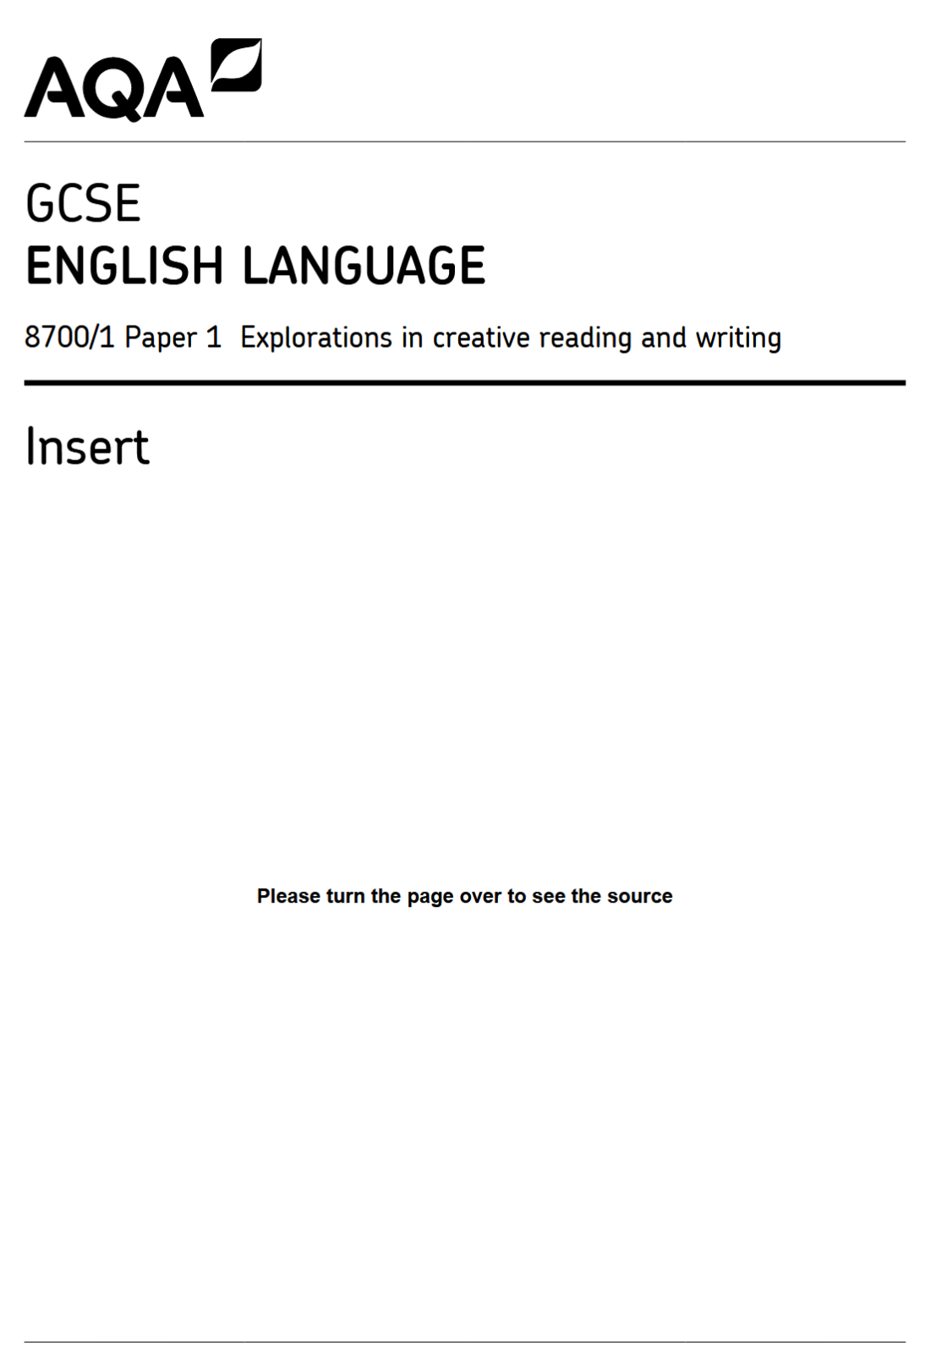

June 2018 - Jigs and Reels by Joanne Harris
Source A is taken from the beginning of a short story written by Joanne Harris. Mr Fisher, a teacher of English for forty years, works at St Oswald’s Grammar School for Boys.

Mr Fisher lived alone in a small terraced house in the centre of town. He did not own a car, 1
and therefore preferred to do as much as he could of his weekend marking in the form room
after school. Even so, there were usually two or three stacks of books and papers to take
home on the bus. 4

It had been a disappointing term at St Oswald’s. For most of the boys in 3F, creative 5
writing was on a par with country dancing and food technology. Oh, he’d tried to engage
their interest. But books just didn’t seem to kindle the same enthusiasm as they had in the
old days.

Mr Fisher remembered a time – surely, not so long ago – when books were golden, when 9
imaginations soared, when the world was filled with stories which ran like gazelles and 10
pounced like tigers and exploded like rockets, illuminating minds and hearts. He had seen
it happen; had seen whole classes swept away in the fever. In those days, there were
heroes; there were dragons and dinosaurs; there were space adventurers and soldiers of
fortune and giant apes. In those days, thought Mr Fisher, we dreamed in colour, though
films were in black and white, and good always triumphed in the end. 15

Now everything was in black and white, and though Mr Fisher continued to teach with as
much devotion to duty as he had forty years before, he was secretly aware that his voice
had begun to lack conviction. To these boys, these sullen boys with their gelled hair and
perfect teeth, everything was boring. Shakespeare was boring. Dickens was boring.
There didn’t seem to be a single story left in the world that they hadn’t heard before. And 20
over the years, though he had tried to stop it, a terrible disillusionment had crept over Mr
Fisher, who had once dreamed so fiercely of writing stories of his own. They had come to
the end of the seam, he understood. There were no more stories to be written. The magic
had run out.

This was an uncharacteristically gloomy train of thought, and Mr Fisher pushed it away. 25
Not all his boys lacked imagination. Alistair Tibbet, for instance, even though he had
obviously done part of his homework on the bus. An amiable boy, this Tibbet. Not a
brilliant scholar by any means, but there was a spark in him which deserved attention.

Mr Fisher took a deep breath and looked down at Tibbet’s exercise book, trying not to think
of the snow outside and the five o’clock bus he was now almost certain to miss. Four 30
books to go, he told himself; and then home; dinner; bed; the comforting small routine of a
winter weekend.

But, gradually sitting there in the warm classroom with the smell of chalk and floor polish in
his nostrils, Mr Fisher began to experience a very strange sensation. It began as a
tightening in his diaphragm, as if a long unused muscle had been brought into action. His 35
breathing quickened, stopped, quickened again. He began to sweat. And when he
reached the end of the story, Mr Fisher put down his red pen and went back to the
beginning, re-reading every word very slowly and with meticulous care.

This must be what a prospector feels when, discouraged and bankrupt and ready to go
home, he takes off his boot and shakes out a nugget of gold the size of his fist. He read it 40
again, critically this time, marking off the paragraphs with notes in red. A hope, which at
first Mr Fisher had hardly dared to formulate, swelled in him and grew strong. He found
himself beginning to smile.

If anyone had asked him what Tibbet’s story was about, Mr Fisher might have been hard
put to reply. There were themes he recognised, elements of plot which were vaguely 45
familiar: an adventure – a quest, a child, a man. But to explain Tibbet’s story in these terms
was as meaningless as trying to describe a loved one’s face in terms of nose, eyes, mouth.
This was something new. Something entirely original.

