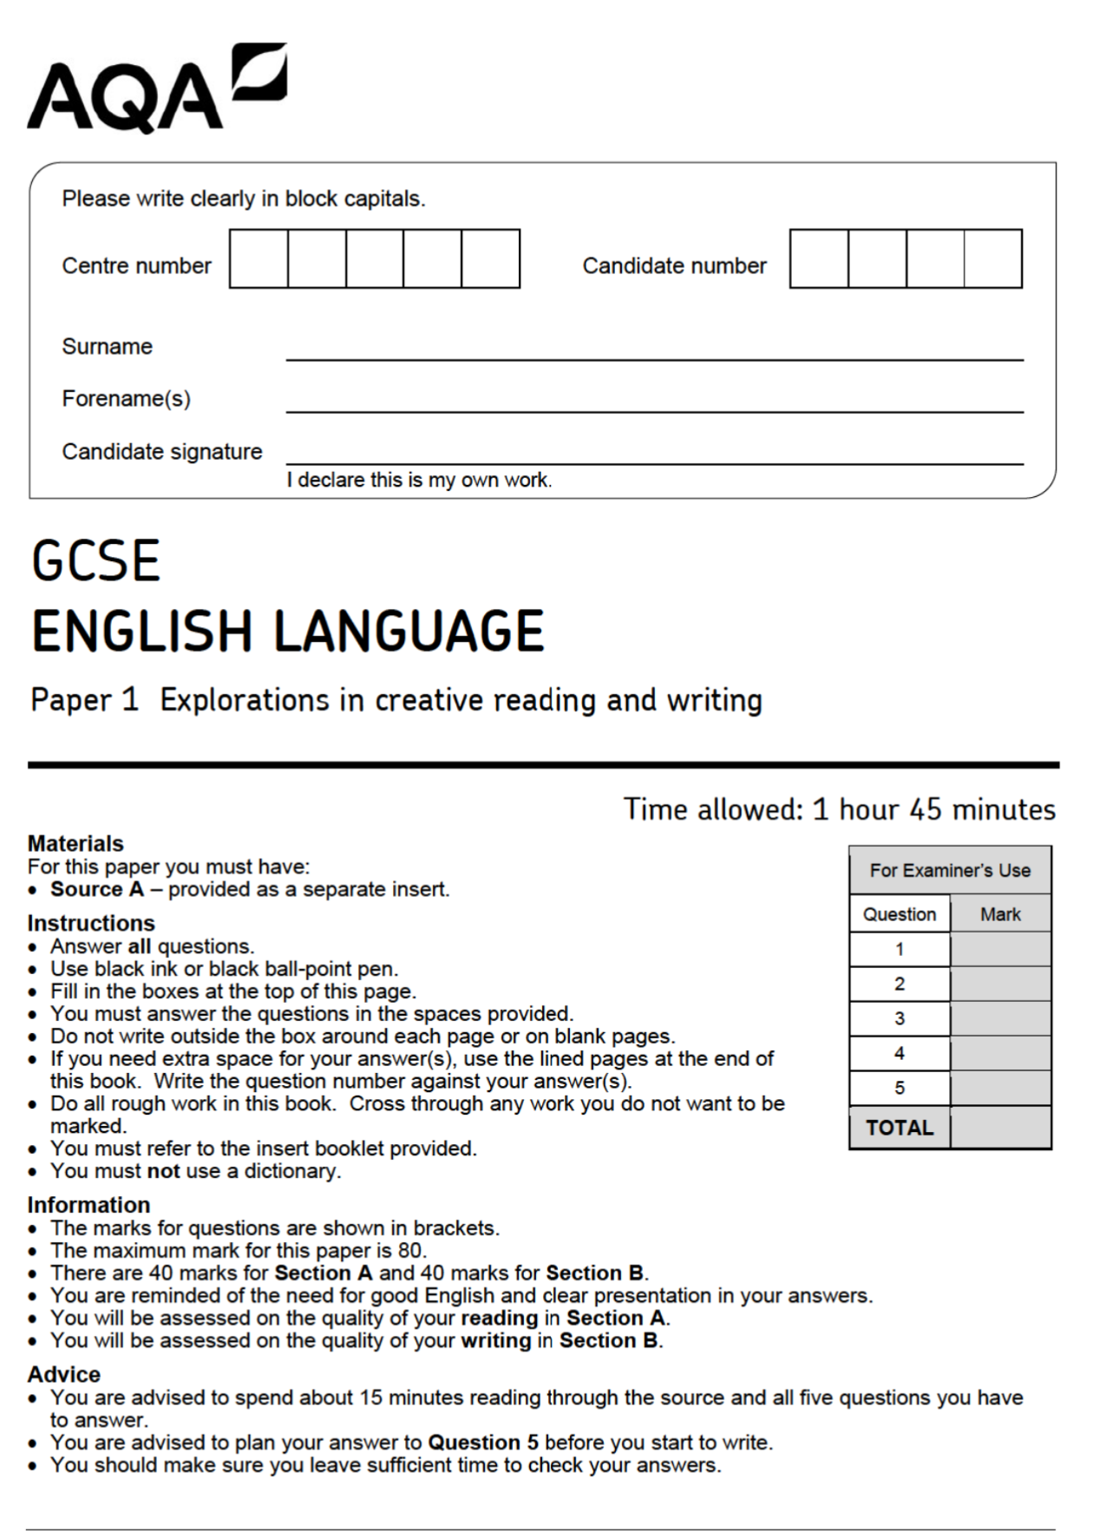
Extract 1 - Questions: Mr Fisher (June 2018)

01: Read again lines 1 to 4.
Answer all part of this question.
Tick (✓) one box for each question.

01.1 What colour has the van been repainted?
Orange
White
Green
[1 mark]
01.2 What colour was the lettering on the sign?
White
Black
Green
[1 mark]
01.3 What was the sign made of?
A flattened board
An old biscuit tin

Cardboard
[1 mark]
01.4 What was the landscape they were driving through like?
Bare with no trees
A forest
Near the sea
[1 mark]
Q2: Read again lines 6 to 12.
Hartop was driving: a thin, angular man, starved-faced. He seemed to occupy
almost all the seat, sprawling awkwardly; so that his wife and their daughter Alice
sat squeezed up, the girl with her arms flat as though ironed against her side, her
thin legs pressed tight together into the size of one. The Hartops’ faces seemed
moulded in clay and in the light from the van-lamps were a flat swede-colour. Like
the man, the two women were thin, with a screwed-up thinness that made them
look both hard and frightened.

How does the writer use language here to convey Mr Fisher’s views on books and stories of the past?
You could include the writer’s choice of:
• Words and phrases
• Language features and techniques
• Sentence forms
[8 marks]

__________________________________________________________________________________________________________________________________________________________________________________________________________________________________________________________________________________________________________________________________________________________________________________________________________________________________________________________________________________________________________________________________________________________________________________________________________________________________________________________________________________________________________________________________________________________________________________________________________________________________________________________________________________________________________________________________________________________________________________________________________________________________________________________________________________________________________________________________________________________________________________________________________________________________________________________________________________________________________________________________________________________________________________________________________________________________________________________________________________________________________________________________________________________________________________________________________________________________________________________________________________________________________________________________________________________________________________________________________________________________________________________________________________________________________________________________________________________________________________________________________________________________________________________________________________________________________________________________________________________________________________________________________________________________________________________________________________________________________________________________________________________________________________________________________________________________________________________________________________________________________________________________________________________________________________________________________________________________________________________________________________________________________________________________________________________________________________________________________________________________________________________________________________________________________________________________________________________________________________________________________________________________________________________________________________________________________________________________________________________________________________________________________________________________________________________________________________________________________________________________________________________________________________________________________________________________________________________________________________________________________________________________________________________________________________________________________________________________________________________________________________________________________________________________________________________________________________________________________________________________________________________________________________________________________________________________________________________________________________________________________________________________________________________________________________________________________________________________________________________________________________________________________________________________________________________________________________________________________________________________________________________________________________________________________________________________________________________________________________________________________________________________________________________________________________________________________________________________________________________________________________________________________________________________________________________________________________________________________________________________________________________________________________________________________________________________________________________________________________________________________________________________________________________________________________________________________________________________________________________________________________________________________________________________________________________________________________________________________________________________________________________________________________________________________________________________________________________________________________________________________________________________________________________________________________________________________________________________________________________________________________________________________________________________________________________________________________________________________________________________________________________________________________________________________________________________________________________________________________________________________________________________________________________________________________________________________________________________________________________________________________________________________________________________
Q3: You now need to think about the structure of the source as a whole.
How has the writer structured the text to create a sense of unfairness?
You could write about:
• How the sense of unfairness has increased or decreased by the end of the source
• How the write uses structure to create an effect
• The writer’s use of any other structural features, such as changes in mood, tone or perspective
[8 marks]

__________________________________________________________________________________________________________________________________________________________________________________________________________________________________________________________________________________________________________________________________________________________________________________________________________________________________________________________________________________________________________________________________________________________________________________________________________________________________________________________________________________________________________________________________________________________________________________________________________________________________________________________________________________________________________________________________________________________________________________________________________________________________________________________________________________________________________________________________________________________________________________________________________________________________________________________________________________________________________________________________________________________________________________________________________________________________________________________________________________________________________________________________________________________________________________________________________________________________________________________________________________________________________________________________________________________________________________________________________________________________________________________________________________________________________________________________________________________________________________________________________________________________________________________________________________________________________________________________________________________________________________________________________________________________________________________________________________________________________________________________________________________________________________________________________________________________________________________________________________________________________________________________________________________________________________________________________________________________________________________________________________________________________________________________________________________________________________________________________________________________________________________________________________________________________________________________________________________________________________________________________________________________________________________________________________________________________________________________________________________________________________________________________________________________________________________________________________________________________________________________________________________________________________________________________________________________________________________________________________________________________________________________________________________________________________________________________________________________________________________________________________________________________________________________________________________________________________________________________________________________________________________________________________________________________________________________________________________________________________________________________________________________________________________________________________________________________________________________________________________________________________________________________________________________________________________________________________________________________________________________________________________________________________________________________________________________________________________________________________________________________________________________________________________________________________________________________________________________________________________________________________________________________________________________________________________________________________________________________________________________________________________________________________________________________________________________________________________________________________________________________________________________________________________________________________________________________________________________________________________________________________________________________________________________________________________________________________________________________________________________________________________________________________________________________________________________________________________________________________________________________________________________________________________________________________________________________________________________________________________________________________________________________________________________________________________________________________________________________________________________________________________________________________________________________________________________________________________________________________________________________________________________________________________________________________________________________________________________________________________________________________________________________________________________________________________________________________________________________________________________________________________________________________________________________________________________________________________________________________________________________________________________________________________________________
Q4: Focus this part of your answer from line 25 to the end of the extract.
In this part of the source, where Alice is sent back along the road to find what has fallen from the roof and returns with the chrysanthemums, shows how hard and cruel Hartop is, so that all our sympathy is with Alice.
To what extent do you agree or disagree with this statement?
In your response, you could:
• consider your impressions of Hartop’s words and actions
• comment on the methods the writer uses to present Hartop’s words and actions
• support your response with references to the text
[20 marks]

________________________________________________________________________________________________________________________________________________________________________________________________________________________________________________________________________________________________________________________________________________________________________________________________________________________________________________________________________________________________________________________________________________________________________________________________________________________________________________________________________________________________________________________________________________________________________________________________________________________________________________________________________________________________________________________________________________________________________________________________________________________________________________________________________________________________________________________________________________________________________________________________________________________________________________________________________________________________________________________________________________________________________________________________________________________________________________________________________________________________________________________________________________________________________________________________________________________________________________________________________________________________________________________________________________________________________________________________________________________________________________________________________________________________________________________________________________________________________________________________________________________________________________________________________________________________________________________________________________________________________________________________________________________________________________________________________________________________________________________________________________________________________________________________________________________________________________________________________________________________________________________________________________________________________________________________________________________________________________________________________________________________________________________________________________________________________________________________________________________________________________________________________________________________________________________________________________________________________________________________________________________________________________________________________________________________________________________________________________________________________________________________________________________________________________________________________________________________________________________________________________________________________________________________________________________________________________________________________________________________________________________________________________________________________________________________________________________________________________________________________________________________________________________________________________________________________________________________________________________________________________________________________________________________________________________________________________________________________________________________________________________________________________________________________________________________________________________________________________________________________________________________________________________________________________________________________________________________________________________________________________________________________________________________________________________________________________________________________________________________________________________________________________________________________________________________________________________________________________________________________________________________________________________________________________________________________________________________________________________________________________________________________________________________________________________________________________________________________________________________________________________________________________________________________________________________________________________________________________________________________________________________________________________________________________________________________________________________________________________________________________________________________________________________________________________________________________________________________________________________________________________________________________________________________________________________________________________________________________________________________________________________________________________________________________________________________________________________________________________________________________________________________________________________________________________________________________________________________________________________________________________________________________________________________________________________________________________________________________________________________________________________________________________________________________________________________________________________________________________________________________________________________________________________________________________________________________________________________________________________________________________________________________________________________________________________________________________________________________________________________________________________________________________________________________________________________________________________________________________________________________________________________________________________________________________________________________________________________________________________________________________________________________________________________________________________________________________________________________________________________________________________________________________________________________________________________________________________________________________________________________________________________________________________________________________________________________________________________________________________________________________________________________________________________________________________________________________________________________________________________________________________________________________________________________________________________________________________________________________________________________________________________________________________________________________________________________________________________________________________________________________________________________________________________________________________________________________________________________________________________________________________________________________________________________________________________________________________________________________________________________________________________________________________________________________________________________________________________________________________________________________________________________________________________________________________________________________________________________________________________________________________________________________________________________________________________________________________________________________________________________________________________________________________________________________________________________________________________________________________________________________________________________________________________________________________________________________________________________________________________________________________________________________________________________________________________________________________________________________________________________________________________________________________________________________________________________________________________________________________________________________________________________________________________________________________________________________________________________________________________________________________________________________________________________________________________________________________________________________________________________________________________________________________________________________________________________________________________________________________________________________________________________________________________________________________________________________________________________________________________________________________________________________________________________________________________________________________________________________________________________________________________________________________________________________________________________________________________________________________________________________________________________________________________________________________________________________________________________________________________________________________________________________________________________________________________________________________________________________________________________________________________________________________________________________________________________________________________________________________________________________________________________________________________________________________________________________________________________________________________________________________________________________________________________________________________




